**User Guide for the Victoria Crash Analysis Tool**

**Summary of Contents**

1. Introduction

2. Installation

3. Getting Going

4. Default Interface

5. Data Filtering and Graph Generation

6. Data Exporting

7. Programme Exiting Troubleshooting

8. Extra Advice

**1. Introduction**

Thank you for visiting the Victoria crash analysis tool! You can follow the instructions in this user manual to use the software to analyse and display data on traffic accidents. This tool is made to offer insights from data on vehicle collisions in Victoria, Australia.

**2. Installation**

Make sure the following software is installed on your computer before using the Victoria Crash Analysis Tool:

Python (3.6 and above)

Any Python IDE, such as PyCharm,

Python libraries (NumPy, Matplotlib, Sqlite3 and Pandas) that are required.

We don't need to install sqlite3 separately because Python comes with built-in support for SQLite databases.

In your terminal, use the following command to install the necessary libraries:

Once you have these requirements, you can use PyCharm or any of your Python IDE to execute the tool.

**3. Getting Going**

Open your PyCharm or Python IDE and run the programme to launch the Road Crash Data Analysis Tool. The primary user interface will appear when you first log in.

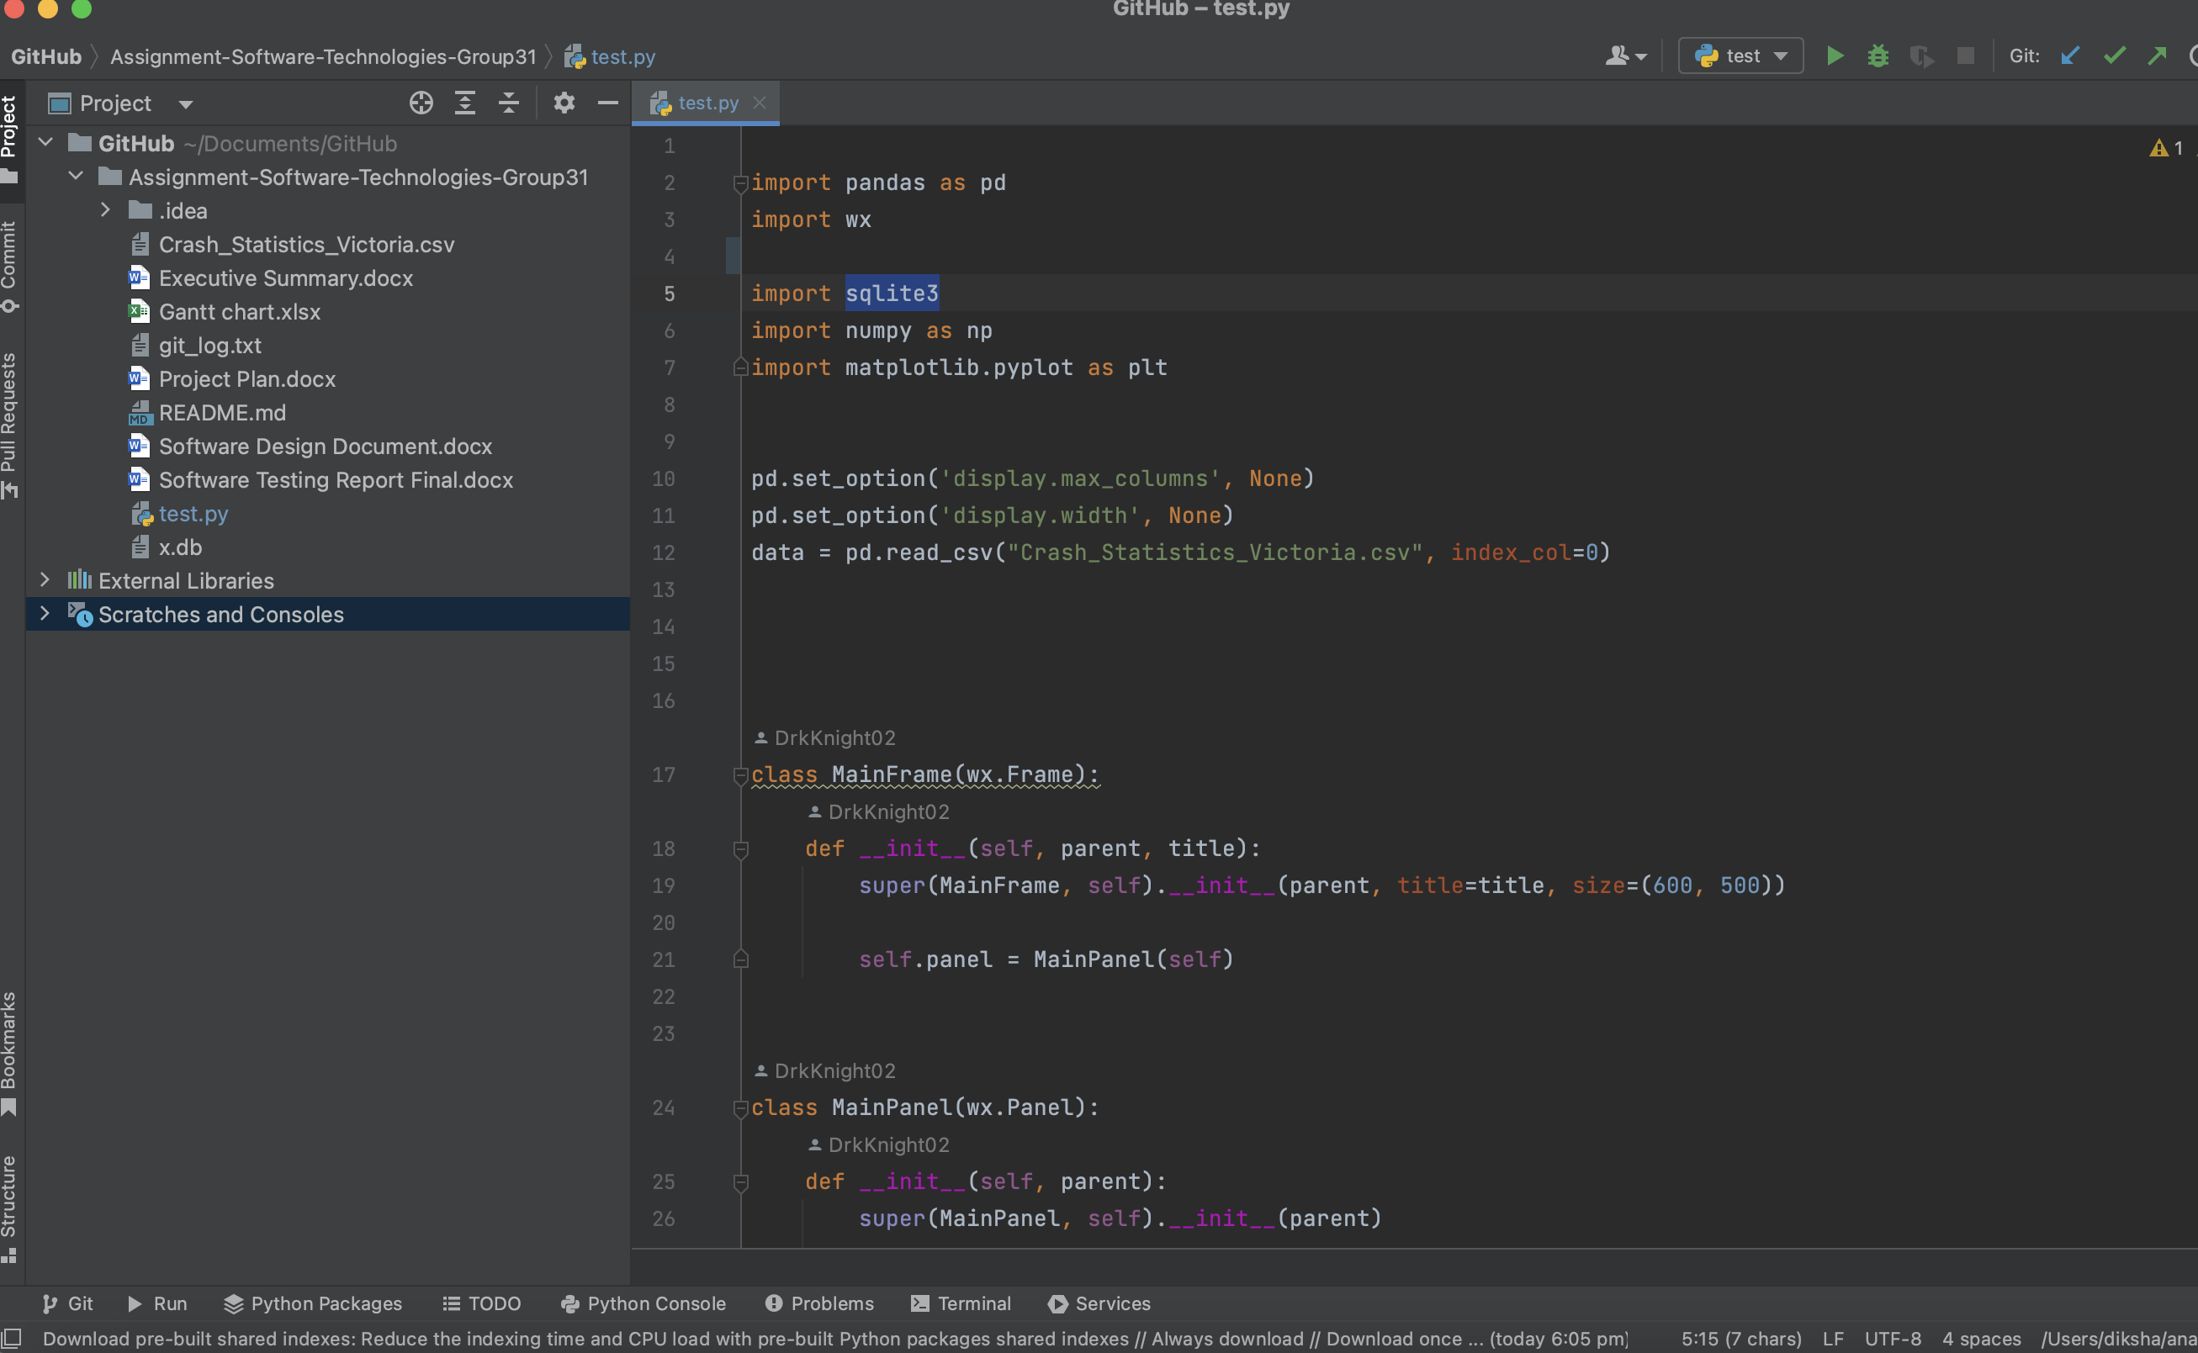

**4. Main Interface**

The program's main interface offers a user-friendly setting. A display area, dropdown menus, and buttons are all included. Here is a summary:

**Date From and Date To:** Choose the date range you want to use to filter the data.

**Keyword Description:** Based on crash descriptions, select keywords to filter data.

**drinking Influence:** Apply a data filter to include or omit accidents that involved drinking.

**Casualties:** Data can be filtered according on the number of casualties.

**Hit-and-runs:** Toggle to include or exclude accidents involving hit-and-runs.

**Graphs:** Click to generate graphs based on the filters you've chosen.

**Display area:** Data and graphs will be provided in this area.

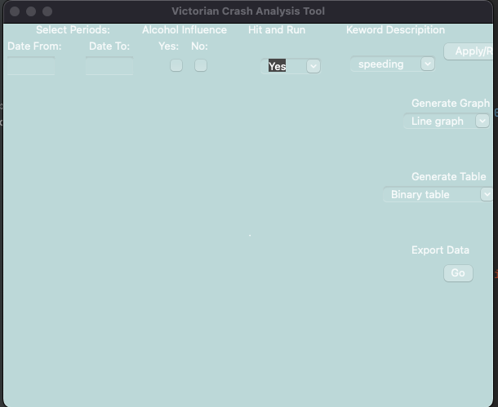

**5. Data Filtering and Graph Generation**

**Date:** Choose a beginning date in the Date from a menu drop-down.

Choose a finish date in the Date menu drop-down.

To filter the data based on your date range, click the "Apply" button.

**By Description of Keyword:** Pick a keyword from the drop-down menu for the keyword description (such as "speeding," "collision," etc.).

To filter the data depending on the chosen keyword, click the "Apply" button.

**Due to alcohol use:** Choose "Yes" or "No" from the Alcohol Influence dropdown menu to filter the data.

To filter data depending on the selected alcohol influence, click the "Apply" button.

**By Number of Casualties:** Choose a casualty amount from the drop-down menu (for instance, "2" for two casualties).

To filter data depending on the selected casualty amount, click the "Apply" button.

**Hit-and-run:** To include or exclude hit-and-run accidents, toggle the Hit and Run button.

The main area will display the filtered data.

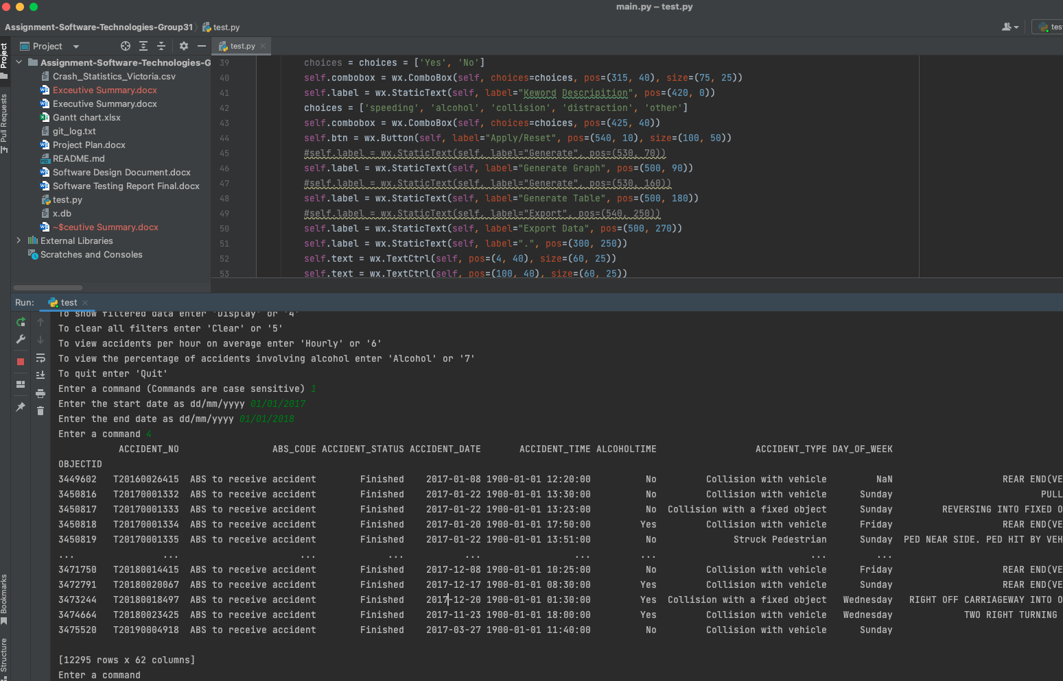

**Creating Graphs:** Click "Generate Graph" after applying the criteria you want.

Based on the filtered data, the programme will produce a graph that offers visual insights.

Depending on your choices, graphs can be bar graphs, line graphs, or pie charts.

**6. Data Exporting**

Unfortunately, this version of the utility does not support data export. To manually save the data seen on the screen, you can take screenshots or notes.

**7. Programme Exiting Troubleshooting:**

You can stop the programme by:

Close the terminal, PyCharm or Python IDE window. If you're using the command line to run the programme, type "quit" or "exit" in the terminal.

Please make sure you have the necessary prerequisites installed before using the Victoria Crash Analysis Tool, and carefully read and follow the directions in this manual if you experience any problems. Please feel free to ask for help if issues continue.

**8. Extra Advice**

If you want to do a different data analysis, remember to reset the filters.

To obtain a greater understanding of the statistics around traffic crashes, experiment with different filter and graph combinations.

Remember that this tool is constantly being updated with fresh data, giving you fresh perspectives over time.

We appreciate you making use of the Victoria crash analysis tool. We believe that using this tool will give you insightful knowledge on Australian Victoria's traffic safety.